Install & Activate Steps(英文)

iOS Installation Steps
- Go to Settings and connect to a‑Wi‑Fi network.
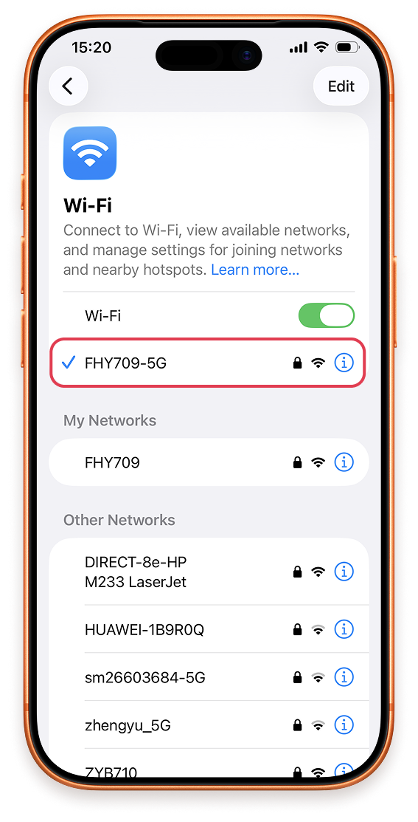
- Settings——Cellular——Tap Add eSIM
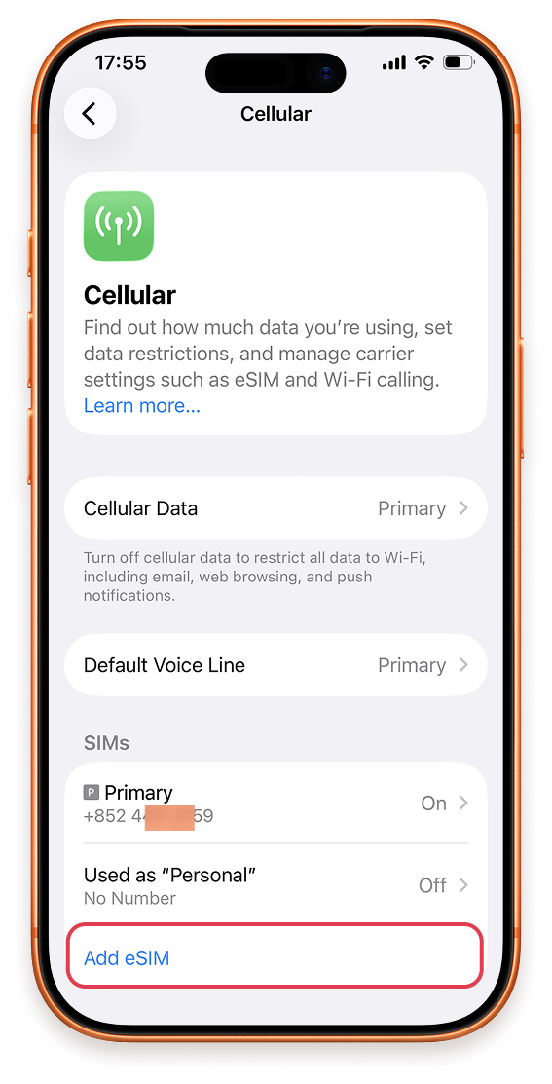
- Tap Use QR Code.
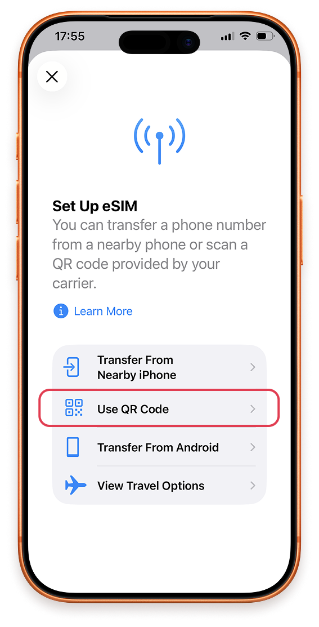
- Tap Scan QR Code.
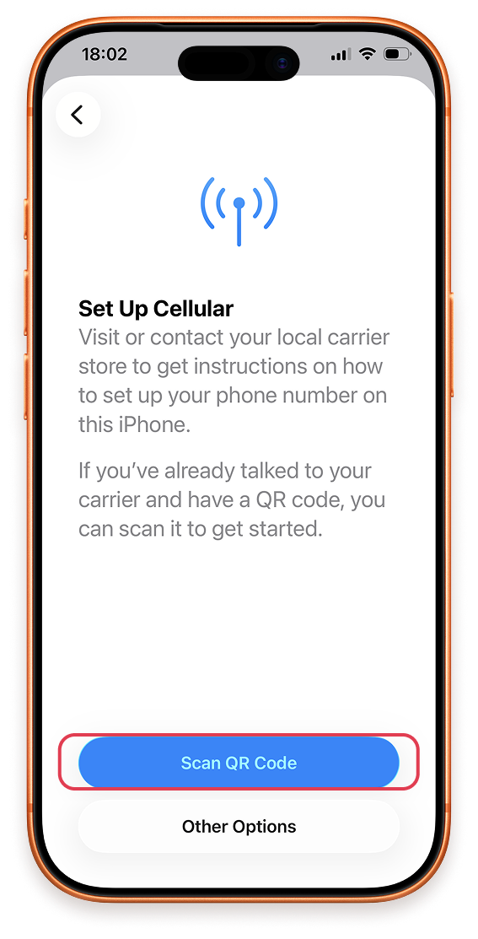
- Scan the QR code provided by Tiger eSIM, then wait for a moment.
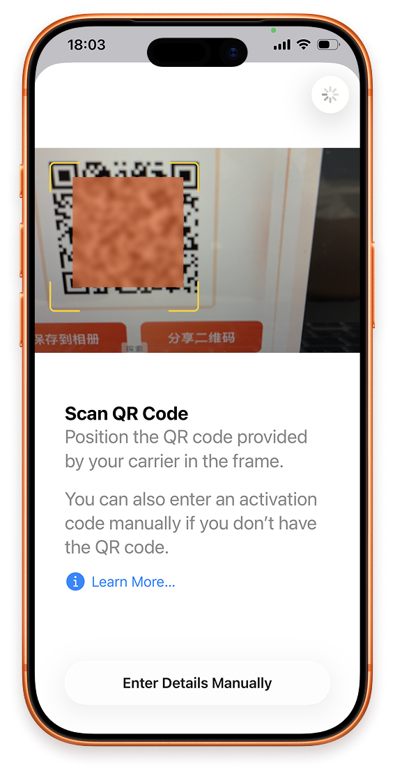
- Activate eSIM, tap Continue to start
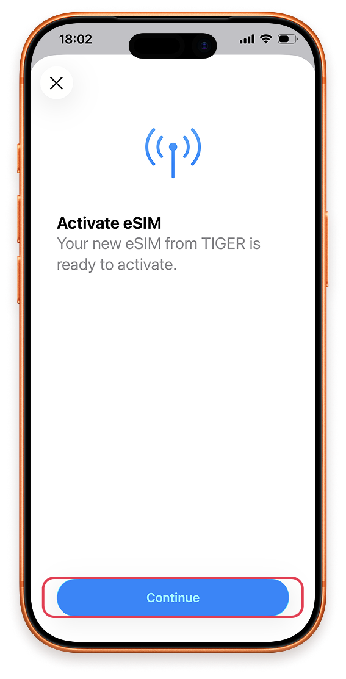
- Select usage label for this eSIM and tap Continue.
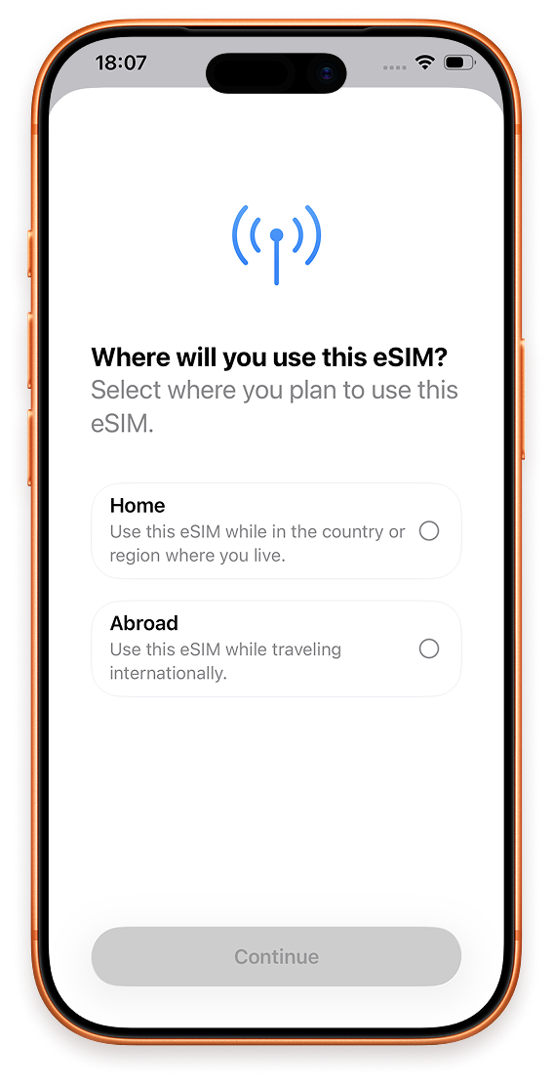

- Important Reminder: After installation completes, go to Settings > Cellular > [your new eSIM], then turn on Data Roaming. Internet access will only work with Data Roaming enabled.
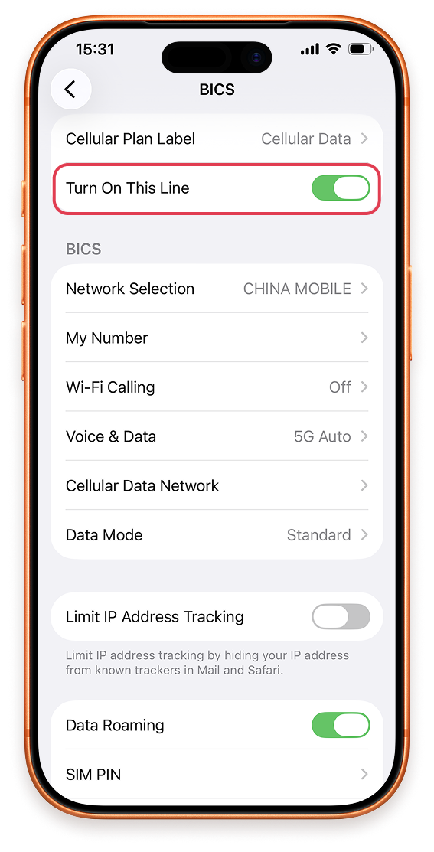
- If you cannot scan the QR code, you can click Enter Details Manually below the QR code scanning viewfinder to Enter Activation Code input page. Copy the SM-DP+Address and Activation Code below Tiger eSIM Manual Install
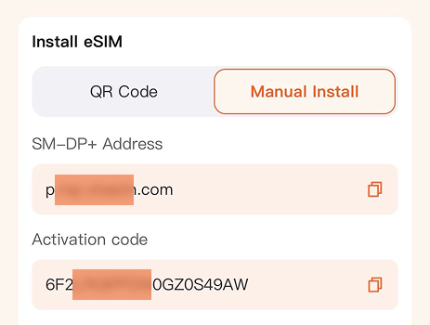

- And paste them into the input . No Confirmation code is required. Click Next and repeat the above steps to activate.
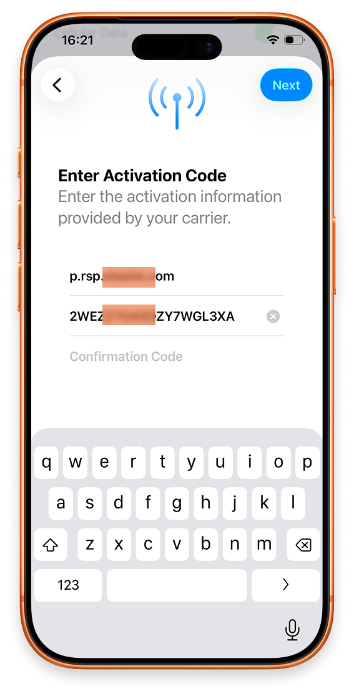

Android Installation Steps
- Open Settings, tap Connections or Network & internet, then connect to Wi‑Fi.
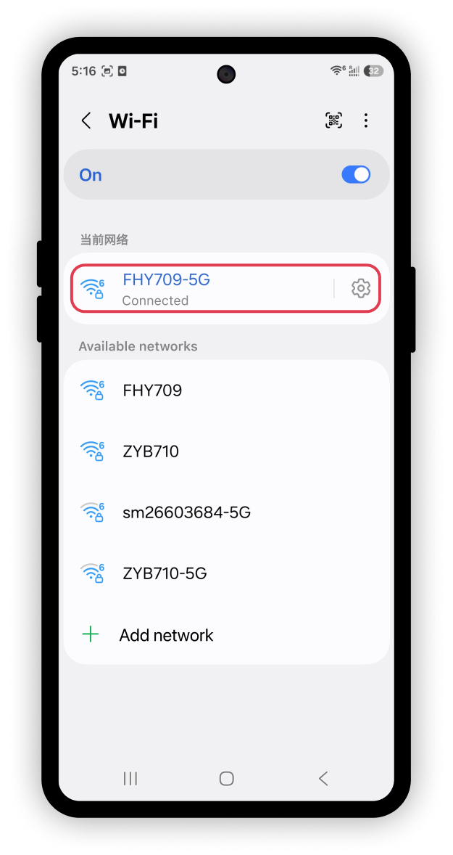
- Tap SIM manager or SIM cards & mobile networks.
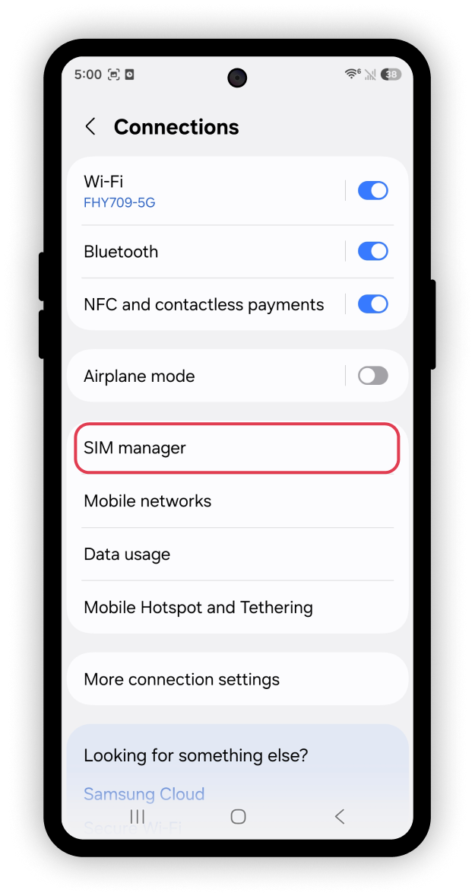

- Tap Add eSIM or Add mobile plan.
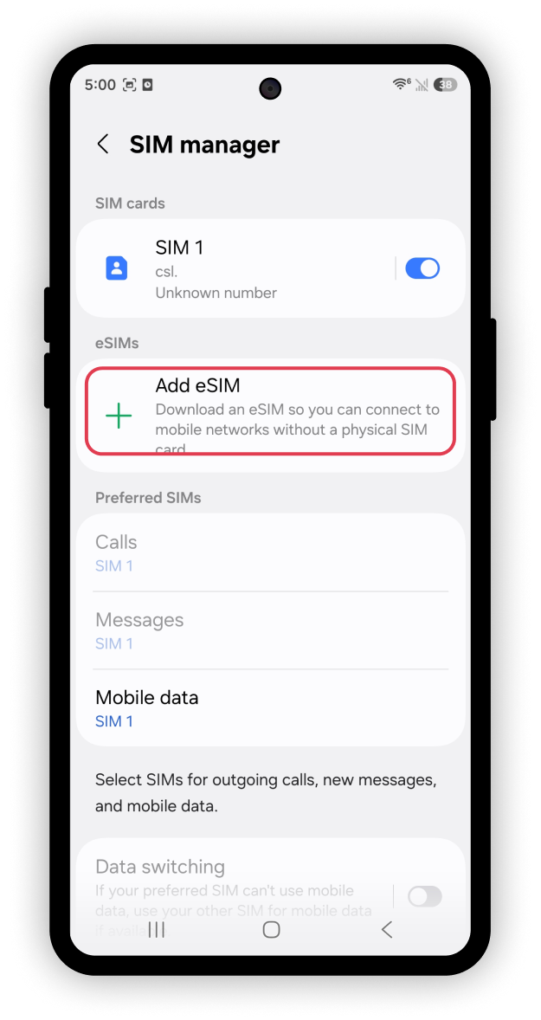
- Select Scan QR code or Scan carrier QR code.
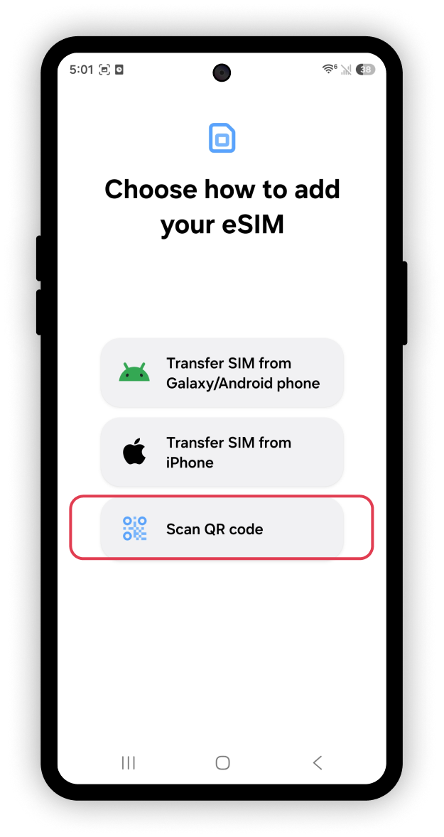

- Point your camera at the Tiger eSIM QR code to scan it.
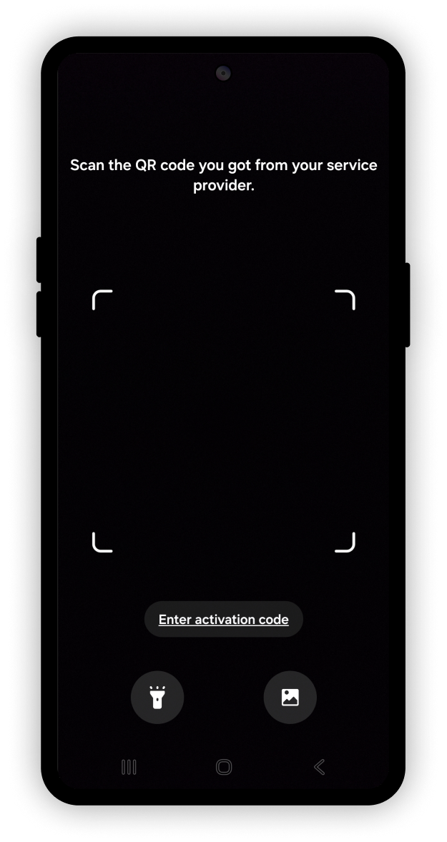

- When prompted Add this eSIM? , tap Add.
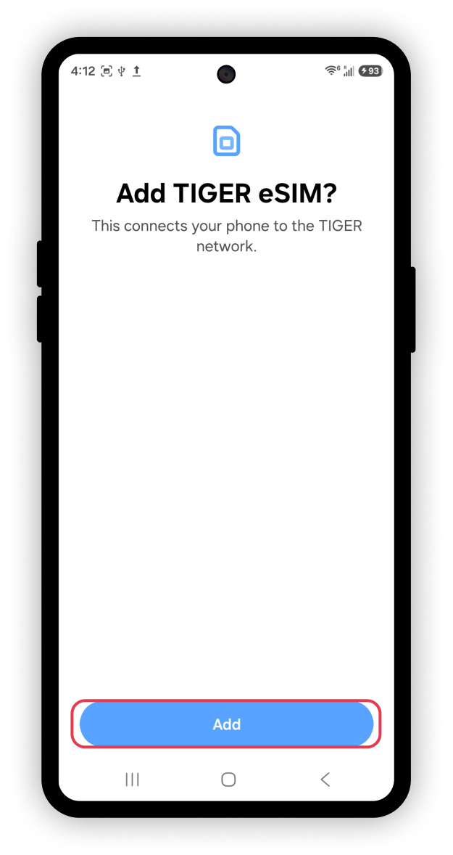
- Wait a few minutes for download and installation to finish.
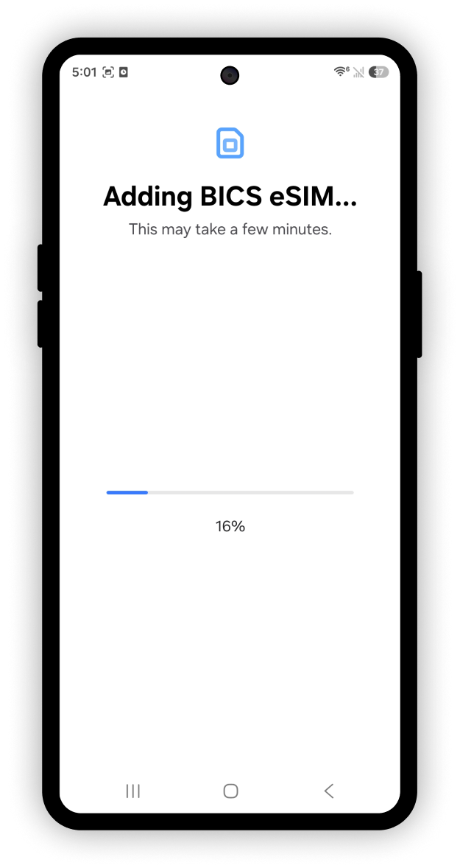
- Once installed, locate the newly‑added eSIM and toggle it On. Set mobile data to use this eSIM profile.
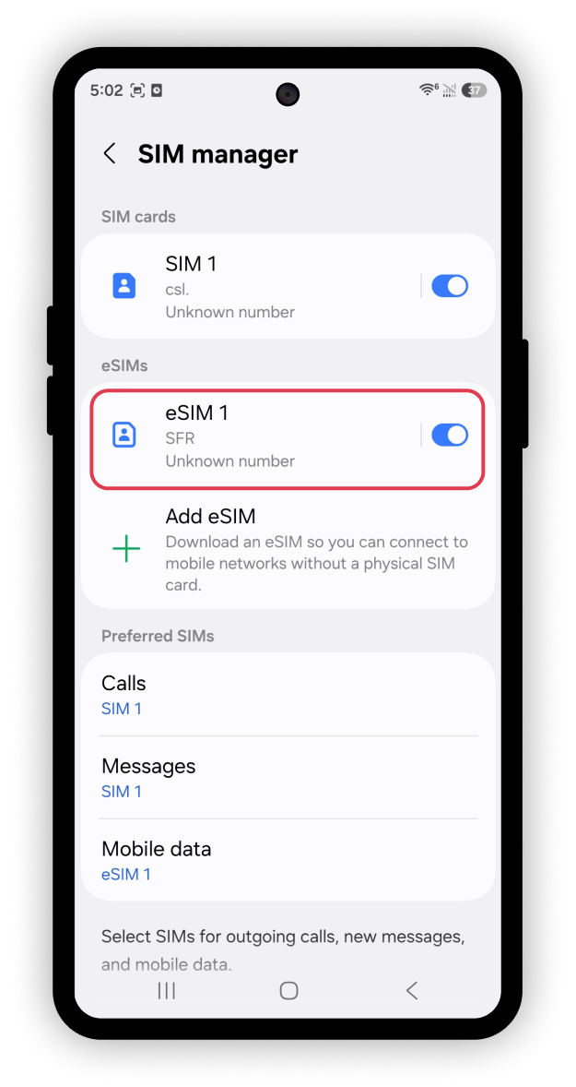
- Important Reminder: After installation, go to Settings > Mobile networks > [Choose eSIM] and enable Data Roaming for internet connectivity. Menu paths vary across brands:
- Huawei: Wireless & networks
- Xiaomi: Dual SIM & mobile networks
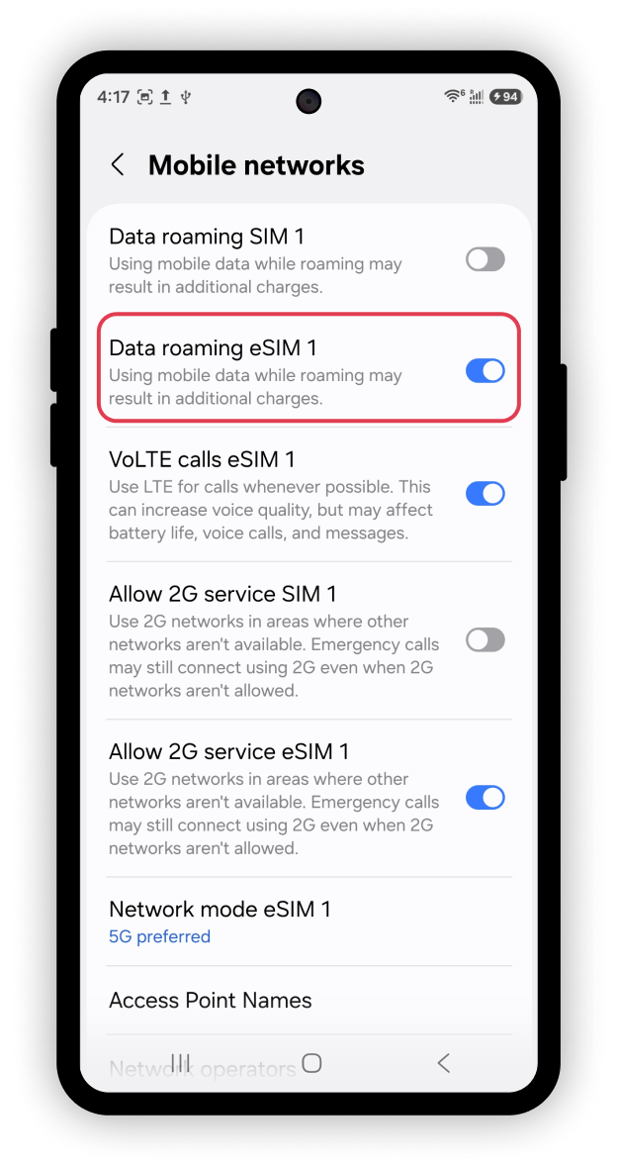
- If you cannot scan the QR code, you can click the Enter Activation Code button below the scan viewfinder, copy the SM—DP+Address and Activation Code provided by Tiger eSIM (Manual install instructions below)

11、And paste them into the input . Click Done and repeat the above steps to activate.
